Questions concerning any visualization –

* What?
* Why?
* How?
* What can information can you derive
* What high level concept will allow you to split datasets apart

14, 2.6, 30, 30, 15, 1000001

* Meaningless without context or semantics – don’t even know if these values are measuring same thing

Abstraction

* Data types (and datasets they come from)
  + Items
    - Tables
    - Networks and trees
    - Geometry
    - Clusters / Sets / Lists
  + 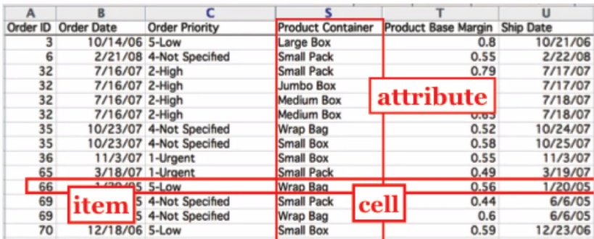Attributes
    - Tables
    - Network / Trees
    - Fields
  + Links
    - Network / Trees
  + Positions
    - Fields
    - 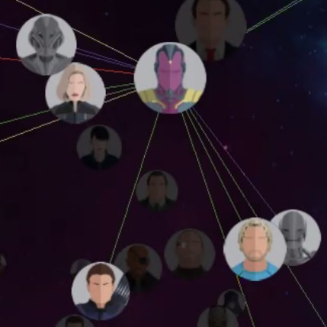Geometry
  + Grids
    - Fields
* Datasets
  + Tables
    - 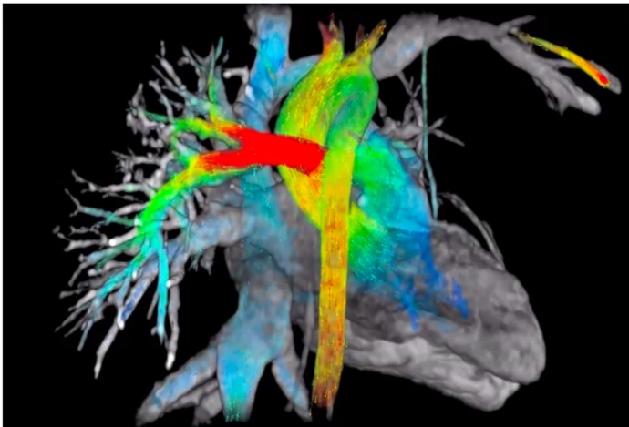Item
    - Attribute Cell
  + Network
    - Items
    - Attributes
    - Links
  + Fields
    - Attributes
    - Positions
    - Grids
  + Geometry
    - Similar to a field – NOT CONTINOUS
    - Fields can only be used for a population in which every position has data (even if sample doesn’t)
* Attribute types
  + Categorial
    - Arbitrary label in which you can’t interpret any form of meaningful order
    - Eg item ID
  + Ordinal
    - Eg review scores, discrete sizes
  + Quantitative
    - Meaningful magnitude, can do arithmetic
    - Dates, lat/long, measurements, counts and amounts